***WMU News***

Our WMU Ladies have been extremely busy the last couple of months and we have a lot we can be proud of.

I attended an Associational WMU meeting on Sunday, January 17th and learned that all churches that participated in the Red Box Ministry collected 1600 pairs of crew socks for women in prison. Any late socks that came in were sent to local nursing homes. Thank you ladies for our participation and for giving to this Mission Project.

On Tuesday, February 9th there will be a Mission Rally for men, women and youth at Hyde Park Baptist Church. A meal will be provided at 6:00 PM with a program from 6:50 – 8:30. They must have a head count for the meal. Anyone interested in attending please let us know.

On Sunday, February 14h we will have our Baptist Women’s Day. Ladies it will be our turn to shine and have the men as proud of us as we were of them on Baptist Men’s Day. We need a choir full on that day.

Praises and shouts can be given. To date we have collected **$10,266.95 for Lottie Moon**. Thank you for giving and supporting Foreign Missions. We exceeded our goal of $10,000.00!!!

For our January mission project our ladies baked cookies and they were delivered to the Lumberton Fire Departments following our YAH meeting.

Looking forward to seeing you on Monday night, February 1st at 6:00 PM for our February meeting in which we will do our Baptist Women’s Day planning.

***Brenda Pittman***

Godwin Heights Baptist Church

Praising God, Equipping the Saints, and Evangelizing the Lost!

***From the Pastor’s Desk... February, 2016***

Happy February!

In order to graduate from college I needed to take two summer courses. For one of those I chose Oceanography and Meteorology. We watched weather patterns and did our best to predict future events. My professor shared with us a little secret: it’s not an exact science and most weather predictions are not accurate more than three or four days out. So when the snowstorm that many projected to come our way didn’t, I wasn’t surprised.

But I was glad we were prepared. In the event of inclement weather I have asked our deacons to check on their flock families, especially those who are older and shut-in. If we have to cancel or postpone services we will get the word out by our calling tree, by posting on social media, and by local television and radio. Know that if you receive a call from the phone tree, the number will appear as the church’s phone number. If you are not receiving any of the phone tree messages or you would like us to call a different number, please contact Margie in the church office and let her know.

We're trying to use several different avenues for getting out information. We're looking to find a happy medium in the number of calls we place with the phone tree. As a general rule, we save it for special events, death and funeral announcements, and other concerns that impact a large portion of the congregation. I hope you have found it as useful as I have.

See you on Sunday!

Your pastor and friend,

**Non-Profit**

**US Postage Paid**

**Lumberton, N. C.**

**Permit No. 79**

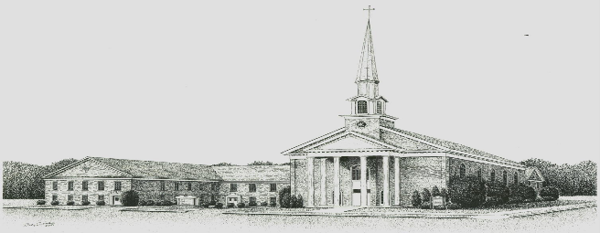

**Godwin Heights Baptist Church**

**Pastor Rev. David Hawes**

**Minister of Youth Rev. Leslie Sessoms**

**Minister of Music Rev. Brenda Flowers**

**Pianist Gayla Johnson**

**Pianist Betsy Wilson**

**Deacon Chairman J. I. Britt**

**Administrative Assistant Marjorie Martin**

**Church Office Hours**

**Monday, Tuesday, Thursday**

**9:30 AM - 12:00 PM 1:00 PM - 3:00 PM**

**Wednesday**

**9:30 AM - 12:00 PM 1:00 PM - 5:00 PM**

**Friday**

**9:30 AM - 12:00 PM**

**Office Phone - (910)739 - 7574 Fax (910) 739 - 7546**

**Email: ghbc@ncrrbiz.com Website: godwinbc.com**

**704 Godwin Avenue**

**Lumberton, N. C. 28358**

**Return Services Requested**