Godwin Heights Baptist Church

Praising God, Equipping the Saints, and Evangelizing the Lost!

***From the Pastor’s Desk... June, 2016***

It’s Monday morning as I sit to write this and Memorial Day Weekend is upon us. With that great day of remembrance of our fallen heroes begins the summer season. Soon schools will empty and vacations will begin. Summer is here.

We have a number of activities planned for June beginning with Sports Camp for grades k-6 on June 13. From swimming to putt-putt to bowling and a day at Jumpin’ Monkeys, there’s a lot of fun packed into that week. At the end of the month, I’ll be taking a group of children to PassportKids camp in Spartanburg, SC. This will be an exciting week as the children learn about God’s work in the world.

The church recently acquired a couple of AEDs (Automated External Defibrillators) and will be offering a special training for their use on Wednesday June 15. In the summer time it is easy to over-exert yourself and do harm to your body. We want to be provide help in the event a medical emergency. We hope you’ll sign up for this special training opportunity. As warmer weather comes I encourage you to be safe and drink plenty of fluids. Check in on our shut-ins and make sure they are okay.

June 12 is going to be a very special day in the life of our church. On that day we will celebrate 20 years with Rev. Leslie Sessoms as our Minister of Youth. Over those year she has faithfully led our children to become the young adults they are today. She has shared Jesus with them, ministered to and with them and loved them. On June 12, let’s pack out the Sanctuary and with all our voices combined say, “Thank you.”

See you Sunday!

Your Pastor and friend,

[](https://www.google.com/url?sa=i&rct=j&q=&esrc=s&source=images&cd=&cad=rja&uact=8&ved=0ahUKEwiOnpeQ2s_MAhUDOiYKHYuDAcsQjRwIBw&url=https://www.pinterest.com/pin/325455510545907521/&psig=AFQjCNFSbsY5kXZf6hhHP74ZJBvSpSqXNw&ust=1462975649863260)

**Non-Profit**

**US Postage Paid**

**Lumberton, N. C.**

**Permit No. 79**

[](https://www.google.com/url?sa=i&rct=j&q=&esrc=s&source=images&cd=&cad=rja&uact=8&ved=&url=http://www.canstockphoto.com/illustration/necktie.html&bvm=bv.121421273,d.eWE&psig=AFQjCNFinrv0dNExpGzYrSNnkgxmqFibqA&ust=1462976544482030)

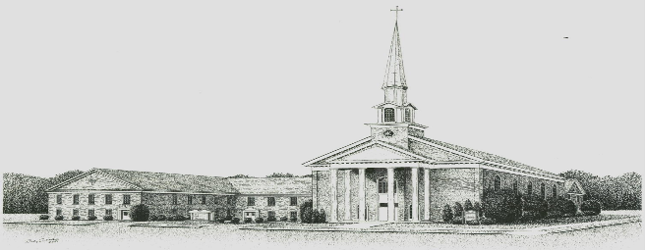

**Sunday, June 19, 2016**

***Godwin Heights Baptist Church***

**Pastor Rev. David Hawes**

**Minister of Youth Rev. Leslie Sessoms**

**Minister of Music Rev. Brenda Flowers**

**Organist Alan Johnson**

**Pianist Gayla Johnson**

**Pianist Betsy Wilson**

**Deacon Chairman J. I. Britt**

**Administrative Assistant Marjorie Martin**

**Church Office Hours**

**Monday, Tuesday, Thursday**

**9:30 AM - 12:00 PM 1:00 PM - 3:00 PM**

**Wednesday**

**9:30 AM - 12:00 PM 1:00 PM - 5:00 PM**

**Friday**

**9:30 AM - 12:00 PM**

**Office Phone - (910)739 - 7574 Fax (910) 739 - 7546**

**Email: ghbc@ncrrbiz.com Website: godwinbc.com**

**704 Godwin Avenue**

**Lumberton, N. C. 28358**

**Return Services Requested**