Godwin Heights Baptist Church

Praising God, Equipping the Saints, and Evangelizing the Lost!

***From the Pastor’s Desk... March, 2016***

I love a good movie or a good book. A good story has the ability to take you to another place, another world and through the images on the screen or the words on the page, to speak to us and move us in profound ways.

We have the grandest and greatest story to tell: that the great God of the Universe who made us and loves us, took on our likeness and became one of us. He lived and walked among us, teaching and ministering and healing. The rulers of the world had him put to death, but death and the grave could not defeat the love of God!

This is the great story that has been trusted to us to share. It is indeed good news! And as we walk through this next month we will live again that final week leading to the cross. We’ll mourn Jesus’ death and we will wake up at dawn and race to the empty tomb (cemetery) and find it empty. Hallelujah!

Tell that story! Share that story, the truest story of them all! Jesus is Lord!

I love to tell the story of unseen things above, I love to tell the story, ’tis pleasant to repeat,

Of Jesus and His glory, of Jesus and His love; What seems each time I tell it more wonderfully sweet;

I love to tell the story, because I know ’tis true, I love to tell the story, for some have never heard

It satisfies my longings as nothing else would do. The message of salvation from God’s own holy Word.

I love to tell the story, for those who know it best I love to tell the story

Seem hungering and thirsting to hear it like the rest; T’will be my theme in glory

And when in scenes of glory I sing the new, new song, To tell the old, old story

Twill be the old, old story that I have loved so long. Of Jesus and His love.

See you Sunday!

Your pastor and friend,

[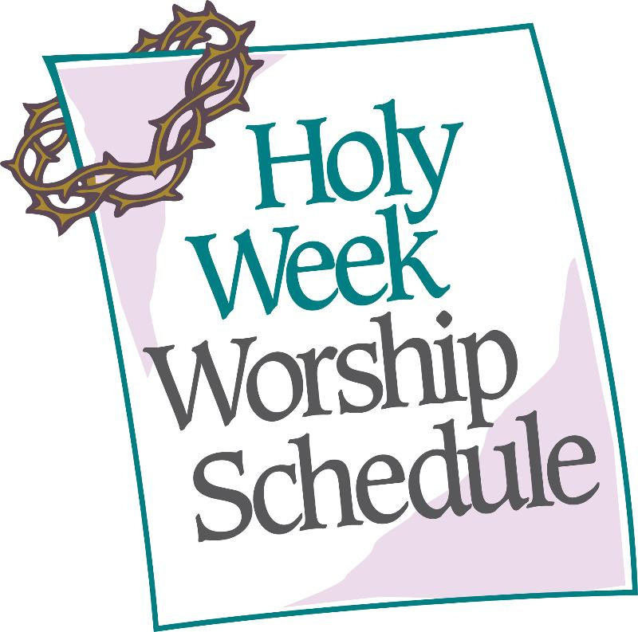](https://www.google.com/url?sa=i&rct=j&q=&esrc=s&source=images&cd=&cad=rja&uact=8&ved=0ahUKEwjErJucqI7LAhXB7CYKHWcJCBIQjRwIBw&url=http://archive.constantcontact.com/fs107/1104713005121/archive/1112660868964.html&bvm=bv.114733917,d.eWE&psig=AFQjCNGnfSm4B1LfRkNlgTUbN_IaYWKHlw&ust=1456331346805321)

**Sunday, March 20th – Psalm Sunday**

**Monday, March 21st at Chestnut Street UMC**

**12:00 PM**

*Speaker - Rev. Leslie Sessoms*

**Tuesday, March 22nd First Presbyterian Church**

**12:00 PM**

*Speaker - Rev. Herbert Lowery*

**Wednesday, March 23rd at First Baptist Church**

**12:00 PM**

*Speaker - Rev. David Ruth*

**Thursday, March 24th at GHBC**

**12:00 PM**

*Speaker - Rev. Gene Wayman*

**Thursday, March 24th Maundy Thursday Service**

**at First Baptist Church**

**7:00 PM**

*Speaker - Rev. David Hawes*

**Friday, March 25th at Trinity Episcopal Church**

**12:00 PM**

*Speaker - Rev. Erin Collier*

**Sunday, March 27th – Easter Sunrise Service**

**Non-Profit**

**US Postage Paid**

**Lumberton, N. C.**

**Permit No. 79**

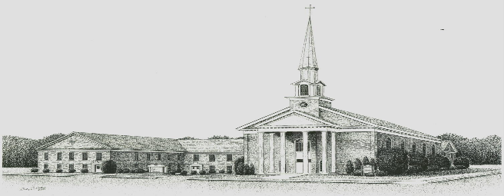

**Godwin Heights Baptist Church**

**Pastor Rev. David Hawes**

**Minister of Youth Rev. Leslie Sessoms**

**Minister of Music Rev. Brenda Flowers**

**Pianist Gayla Johnson**

**Pianist Betsy Wilson**

**Deacon Chairman J. I. Britt**

**Administrative Assistant Marjorie Martin**

**Church Office Hours**

**Monday, Tuesday, Thursday**

**9:30 AM - 12:00 PM 1:00 PM - 3:00 PM**

**Wednesday**

**9:30 AM - 12:00 PM 1:00 PM - 5:00 PM**

**Friday**

**9:30 AM - 12:00 PM**

**Office Phone - (910)739 - 7574 Fax (910) 739 - 7546**

**Email: ghbc@ncrrbiz.com Website: godwinbc.com**

**704 Godwin Avenue**

**Lumberton, N. C. 28358**

**Return Services Requested**