Godwin Heights Baptist Church

Praising God, Equipping the Saints, and Evangelizing the Lost!

***From the Pastor’s Desk... November, 2016***

Church family, I am thankful.

When I stop and take a moment and think about all our city has been through these past few weeks, and when I see all the destruction Mathew left in its wake I cannot help but be thankful. When the church comes together to help its family clean and rebuild or when strangers from all over the country come knock on our door to help, I am thankful.

Hopeforce and Nechama are two of the groups that have been helping our city clean up and rebuild. We have opened our doors to them so they might have a place to sleep. They have mudded out homes, moved furniture, and have done some chainsaw work. They have truly been a godsend to our community and I hope you join me in thanking God for sending them our way.

When you see them, please tell them thanks.

Let us remember those of our own church family who have lost so much. Homes, cars, and businesses were destroyed. May we be the church to them, standing beside them, hand in hand, recovering and rebuilding from what was lost. This work will not end in a week, or even a month. This will take time, and with God’s help, together we will get through this.

This thanksgiving, we truly have much for which to be thankful.

O give thanks to the Lord, for he is good, for his steadfast love endures forever.

-Psalm 136:1

See you Sunday.

Your pastor and friend,

[](https://www.google.com/url?sa=i&rct=j&q=&esrc=s&source=images&cd=&cad=rja&uact=8&ved=&url=http://www.gospelgifs.com/art_pages_01/happy_thanksgiving_19.htm&bvm=bv.135974163,d.cWw&psig=AFQjCNHEZd9kUCXGcIiYGypUx6sA_zEx1g&ust=1476996382264198)

**Non-Profit**

**US Postage Paid**

**Lumberton, N. C.**

**Permit No. 79**

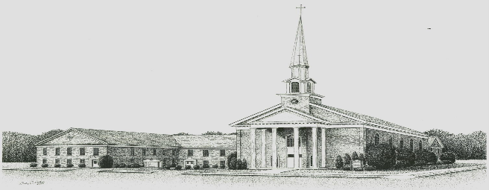

***Godwin Heights Baptist Church***

**Pastor Rev. David Hawes**

**Minister of Youth Rev. Leslie Sessoms**

**Minister of Music Rev. Brenda Flowers**

**Organist Alan Johnson**

**Pianist Gayla Johnson**

**Deacon Chairman Dr. J.C. Humphrey, Jr.**

**Administrative Assistant Marjorie Martin**

**Church Office Hours**

**Monday, Tuesday, Thursday**

**9:30 AM - 12:00 PM 1:00 PM - 3:00 PM**

**Wednesday**

**9:30 AM - 12:00 PM 1:00 PM - 5:00 PM**

**Friday**

**9:30 AM - 12:00 PM**

**Office Phone - (910)739 - 7574 Fax (910) 739 - 7546**

**Email: ghbc@ncrrbiz.com Website: godwinbc.com**

**704 Godwin Avenue**

**Lumberton, N. C. 28358**

**Return Services Requested**