**#**TeamGHBCYouth

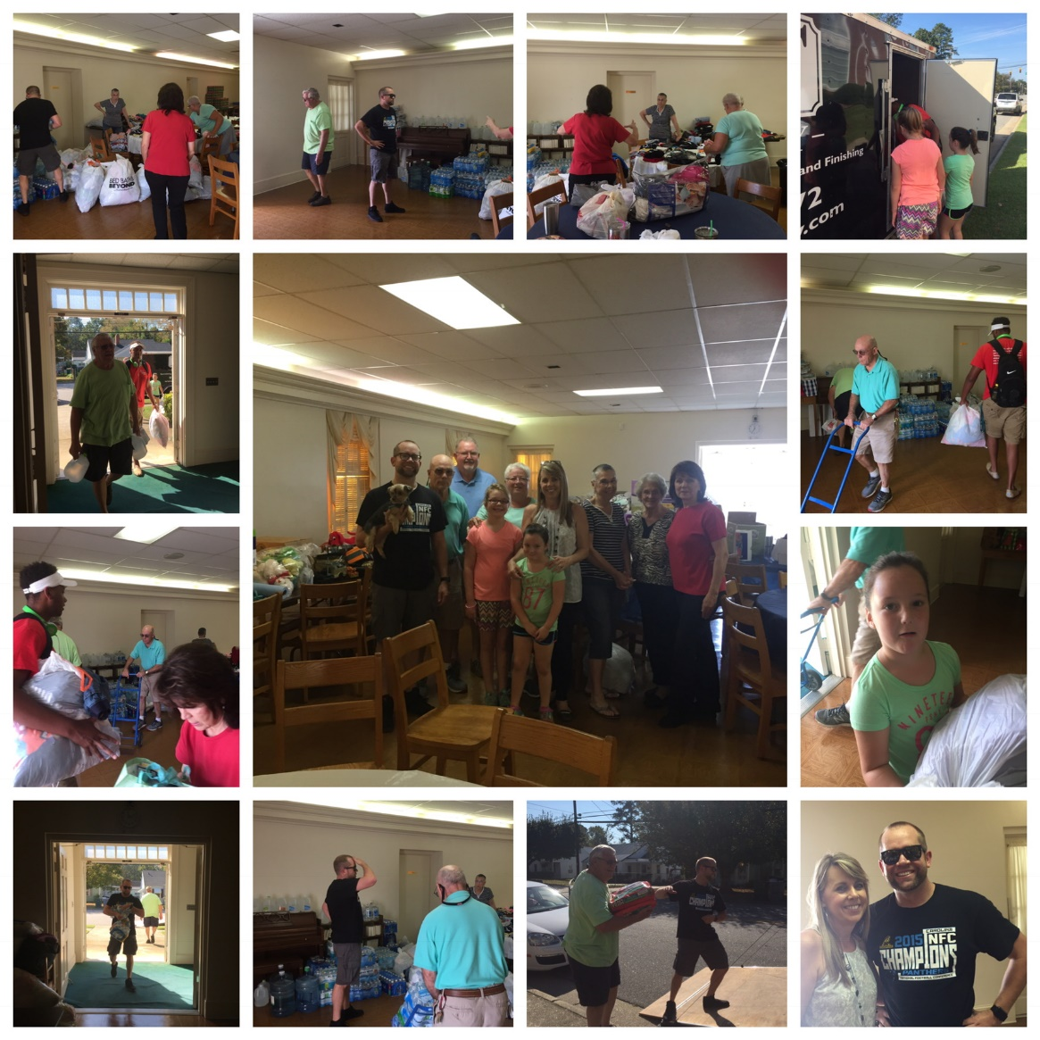

Hurricane Matthew Relief Efforts

Thank you to Jordan Branyon for coming to the

rescue of your home church and community! Thank you to all the volunteers who helped unload, sort and distribute donations!

***Music Notes for October***

This past Sunday in our worship service we sang one of Fanny Crosby’s beautiful hymns, “All The Way My Savior Leads Me.” During difficult times we often become discouraged because we cannot see God’s long range plans for guidance in our lives. No one knows the importance of guided steps as much as a blind person like Fanny Crosby, who lost her sight when she was six weeks old through improper medical treatment. A sightless person is keenly aware there will be stumbling and uncertainty as they continue on their way. As Fanny wrote the words, “Cheers each winding path I tread, gives me grace for every trial,” she reminds us that God has never promised to keep us from difficulties or obstacles in our lives. However, He has assured us that He will go with us, guide our steps, and give us the necessary grace.

In the days ahead it is my prayer that God will help us to find our “perfect rest” in every stressful situation, being confident that He is guiding our every step.

**Fall/Christmas Music** – Please come and join our Worship Choir as we prepare to lead our congregation in worship during the fall, Advent, and Christmas seasons. Anyone interested in singing with our choir is invited to attend rehearsals. The **Worship Choir** rehearses on **Wednesday nights at 7:30 pm.**

**Children’s Music** –Our Children’s Music meets during our Faithsteps program on Wednesday nights. This fall we will be working on a Christmas musical to share with our congregation and parents.

God bless,

Brenda

*“This my song through endless ages, Jesus led me all the way.”*

*Fanny Crosby*

MC900019396[1]

MC900048128[1]