[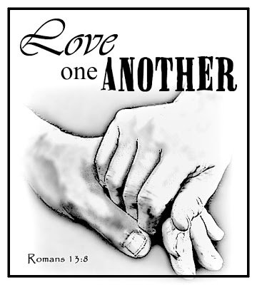](https://www.google.com/url?sa=i&rct=j&q=&esrc=s&source=images&cd=&cad=rja&uact=8&ved=0ahUKEwjU28Wx8MnRAhUFQiYKHU4TCGIQjRwIBw&url=http://quotesgram.com/love-quotes-clip-art/&psig=AFQjCNHBbEJYgoxkDteHHm4wyFDW1VG51Q&ust=1484766105130591)

Godwin Heights Baptist Church

Praising God, Equipping the Saints, and Evangelizing the Lost!

***From the Pastor’s Desk... February, 2017***

Twas the week before Christmas and all through the store, decorations of hearts were put out on the floor. Stores and their sales are seasonally driven. Santa hadn’t arrived and Valentine’s Day decorations, pink and read hearts, chocolates and candies were being set out. Valentine’s: the celebration of love.

Frederick Buechner, in his little book of ABC’s describes love thus:

The first stage is to believe that there is only one kind of love. The middle stage is to believe that there and many kinds of love and that the Greeks had a different word for each of them. The last stage is to believe there is only one kind of love…Of all powers, love is the most powerful and the most powerless. It is the most powerful because it alone can conquer the final and most impregnable stronghold which is the human heart. It is the most powerless because it can do nothing except by consent.

In the Christian sense, love is primarily not an emotion, but an act of the will. When Jesus tells us to love our neighbor, he is not telling us to love them in the sense of a cozy emotional feeling… On the contrary, he is telling us to love our neighbors in the sense of being willing to work for their well-being even if it means sacrificing our own well-being to that end.

As Christians may we not wait for February to come to be about love. May we show the world what love truly means, so that the world “will know we are Christians by our love.” Yes, my friends, love is a verb.

See you Sunday!

With deep love for you all,

your Pastor and friend,

**Non-Profit**

**US Postage Paid**

**Lumberton, N. C.**

**Permit No. 79**

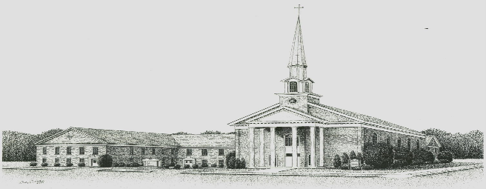

***Godwin Heights Baptist Church***

**Pastor Rev. David Hawes**

**Minister of Youth Rev. Leslie Sessoms**

**Minister of Music Rev. Brenda Flowers**

**Organist Alan Johnson**

**Pianist Gayla Johnson**

**Deacon Chairman Dr. J.C. Humphrey, Jr.**

**Administrative Assistant Marjorie Martin**

**Church Office Hours**

**Monday, Tuesday, Thursday**

**9:30 AM - 12:00 PM 1:00 PM - 3:00 PM**

**Wednesday**

**9:30 AM - 12:00 PM 1:00 PM - 5:00 PM**

**Friday**

**9:30 AM - 12:00 PM**

**Office Phone - (910)739 - 7574 Fax (910) 739 - 7546**

**Email: ghbc@ncrrbiz.com Website: godwinbc.com**

**704 Godwin Avenue**

**Lumberton, N. C. 28358**

**Return Services Requested**